***Part 4 Data Flow Diagram (DFD)***

**4.1 Context-Level DFD**

Figure 4.1 shows the interaction between the system and external agents, including its main system and the database.

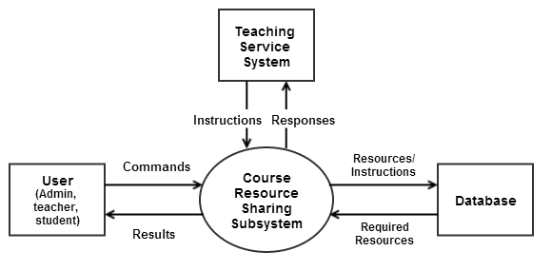

Figure 4.1

**4.2 Level 1 DFD**

Figure 4.2 shows how the Course Resource Sharing Subsystem is divided into several subsystems (processes). It also shows the flow of data between the various parts of the system.

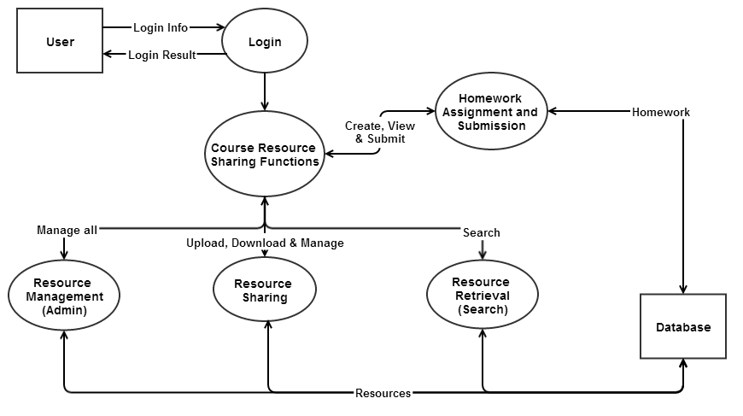

Figure 4.2

**4.3 Level 2 DFD**

The diagrams below show the detailed data flow information within each subsystem under the Course Resources Sharing System.

**4.3.1 Login Processing**

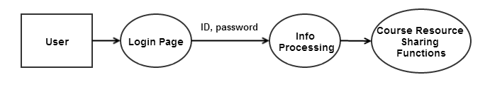

Figure 4.3

**4.3.2 Homework Assignment and Submission**

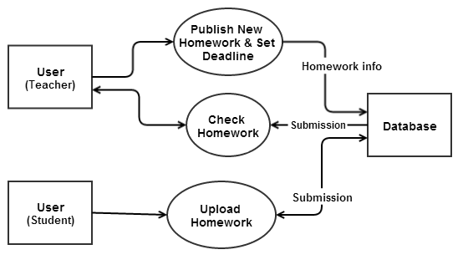

Figure 4.4

**4.3.3 Resources and Homework Management (Administration)**

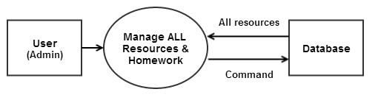

Figure 4.5

**4.3.4 Resources Sharing**

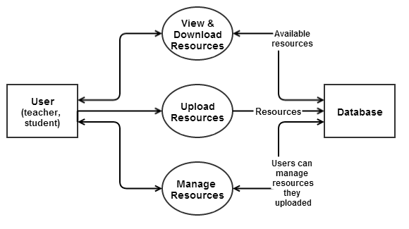

Figure 4.6

**4.3.5 Resources Retrieval (Search)**

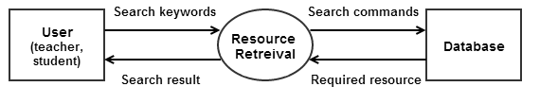

Figure 4.7